|  |  |
| --- | --- |
| Stella Nova Logo | LOGO4 |
| Best Buy Canada Mobile | |
| |  | | --- | | **Customer Feature Document** |   **Document Version: 1.2**  **Design Date: October 28, 2013** | |
| **Prepared By: Amy Lackas** | |
|  | |

**Table of Contents**

*1.* *Feature Overview* 3

1.1 Feature Description 3

1.2 Assumptions 3

1.3 Parameters and System Settings 3

1.4 Interfaces 3

*2.* *USE CASE: Customer* 4

2.1 Feature Flow 4

2.2 Precondition 4

2.3 Main Flow 4

2.4 Alternate Flows 5

2.5 Post Condition 5

2.6 Special Requirements 5

*3.* *Supplemental Specifications* 6

3.1 Electronic Journal 6

3.2 POSLog 6

3.3 Printed Receipts 6

3.4 Suspend Feature 7

*4.* *Screen Layouts* 7

4.1 Customer Search 7

4.2 Customer Search Results 9

4.3 Customer Add 10

4.4 Customer Details 13

4.5 Customer Edit 15

*5.* *Business Sign Off* 17

*6.* *Revision History* 18

7. Appendix A: Source Documentation 18

7.1 Functional Requirements 18

*8.* *Appendix* B*: Glossary* 18

# *Feature Overview*

## Feature Description

The Customer Feature Document describes the functionality of searching for an existing customer by various search criteria and adding a new customer to a basket or item in a transaction. This functionality helps to build customer loyalty, give customers incentive to return and minimize transaction time.

## Assumptions

1. The system only retrieves active customers (e.g. customers that can be displayed).
2. All text displayed by the system is configurable by brand to support multi-language. Text is defined from an external source or defined within the system.
3. When multiple customers are applied during a transaction, the customer information will persist and may be re-applied for subsequent items.

## Parameters and System Settings

|  |  |  |
| --- | --- | --- |
| **Parameter Mnemonic** | **Description** | **Valid Values** |
| Customer Lookup Timeout | Determines the timeout threshold in seconds that is used when the system attempts to contact the Third Party Customer Lookup Service before returning an offline response. | 1-15 |
| Maximum Number of Customer Search Result Rows Per Page | Determines maximum number of customer search result rows displayed per page. |  |
| Maximum Number of Customer Search Result Pages | Determines maximum number of customer search result pages displayed. |  |

## Interfaces

|  |  |
| --- | --- |
| **Interface** | **Description** |
| Customer Lookup Service | Searches for customer information in database. |

# *USE CASE: Customer*

## Feature Flow



## Precondition

* An action requires customer to be captured to continue.

## Main Flow

1. The system prompts the operator to search or add a new customer or to select an existing customer if present in the transaction.
2. If the operator selects an existing customer, the use case ends and the system returns to the calling use case with a linked customer.
3. If the operator selects to add a new customer, the Customer Add alternate flow is executed.
4. The operator enters search criteria to search for a customer and accepts the entry.
5. The system searches for the customer information.
6. If no results are returned or no results are found because the system is offline or the search times out, the system displays a message; the operator acknowledges the message and the Main Flow is restarted.
7. If the search returns a single record, the flow continues where the system displays the customer details and prompts the operator to select an option.
8. If the search returns two or more results, the system displays the search results and prompts the operator to select a customer or select an option.
9. If the operator selects to add a new customer, the Customer Add alternate flow is executed.
10. If the operator selects to search again, the Main Flow is restarted.
11. The operator selects a customer.
12. The system displays the customer details and prompts the operator to select an option.
13. If the operator selects to edit a customer, the Customer Edit alternate flow is executed.
14. The operator selects to continue.
15. The system journals the customer information.
16. The use case ends and the system returns to the calling use case with a linked customer.

## Alternate Flows

### Customer Add

1. The system prompts the operator to enter customer information. **NOTE**: If search completed prior to adding customer, search criteria is prefilled in the customer fields.
2. The operator enters customer details and accepts the entry.
3. The system validates the required entered data.
4. If any required fields are not populated, the system displays a message, the operator acknowledges the message and the alternate flow restarts with the previously entered information as the default.
5. If any fields have the wrong format, the system displays a message, the operator acknowledges the message and the alternate flow restarts with the previously entered information as the default.
6. The system validates the entered postal code.
7. The alternate flow ends and the system returns to the Main Flow.

### Customer Edit

1. The system displays customer information and prompts the operator to edit the information.
2. The operator adds or edits customer information and accepts the entry.
3. The system validates the required entered data.
4. If any required fields are not populated, the system displays a message, the operator acknowledges the message and the alternate flow restarts with the previously entered information as the default.
5. If any fields have the wrong format, the system displays a message, the operator acknowledges the message and the alternate flow restarts with the previously entered information as the default.
6. If the address is new or the postal code is edited, the system validates the entered postal code.
7. The alternate flow ends and the system returns to the Main Flow.

## Post Condition

* Customer has been captured.

## Special Requirements

When communicating with the Third Party Customer Lookup Service, the system treats an offline/timeout response the same as no information found response.

### Special Offline Requirements

TBD

### Data Input/Output

|  |  |  |
| --- | --- | --- |
| Data Element | Description | Destination |
| First Name | Customer’s first name | * E-Journal * POSLog * Customer Database |
| Last Name | Customer’s last name | * E-Journal * POSLog * Customer Database |
| Address Line 1 | Customer’s address line 1 | * E-Journal * POSLog * Customer Database |
| Address Line 2 | Customer’s address line 2 | * E-Journal * POSLog * Customer Database |
| City | Customer’s city | * E-Journal * POSLog * Customer Database |
| Country | Customer’s country | * E-Journal * POSLog * Customer Database |
| State/Region | Customer’s state or region | * E-Journal * POSLog * Customer Database |
| Postal Code | Customer’s ZIP code | * E-Journal * POSLog * Customer Database * Postal code validation is documented in UI Guideline document. |
| Phone Type | Customer phone type associated with the telephone number: Home, Work | * E-Journal * POSLog * Customer Database |
| Telephone No | Customer’s telephone number | * E-Journal * POSLog * Customer Database |
| E-Mail | Customer’s email address | * E-Journal * POSLog * Customer Database |

# *Supplemental Specifications*

## Electronic Journal

Electronic journal mockups for this feature are documented in the BBYC Phase 1 Electronic Journal document.

## POSLog

POSLog mockups for this feature are documented in the BBYC Phase 1 POSLog document.

## Printed Receipts

Printed receipt mockups, where applicable, are documented in the BBYC Phase 1 Receipt document.

## Suspend Feature

The Suspend Use Case is updated to reflect that the data captured prior to suspending a transaction is available when the transaction is resumed.

# *Screen Layouts*

## Customer Search

The Customer Search screen appears when the operator initiates a process that requires a customer to be captured prior to continuing.

### Mockup

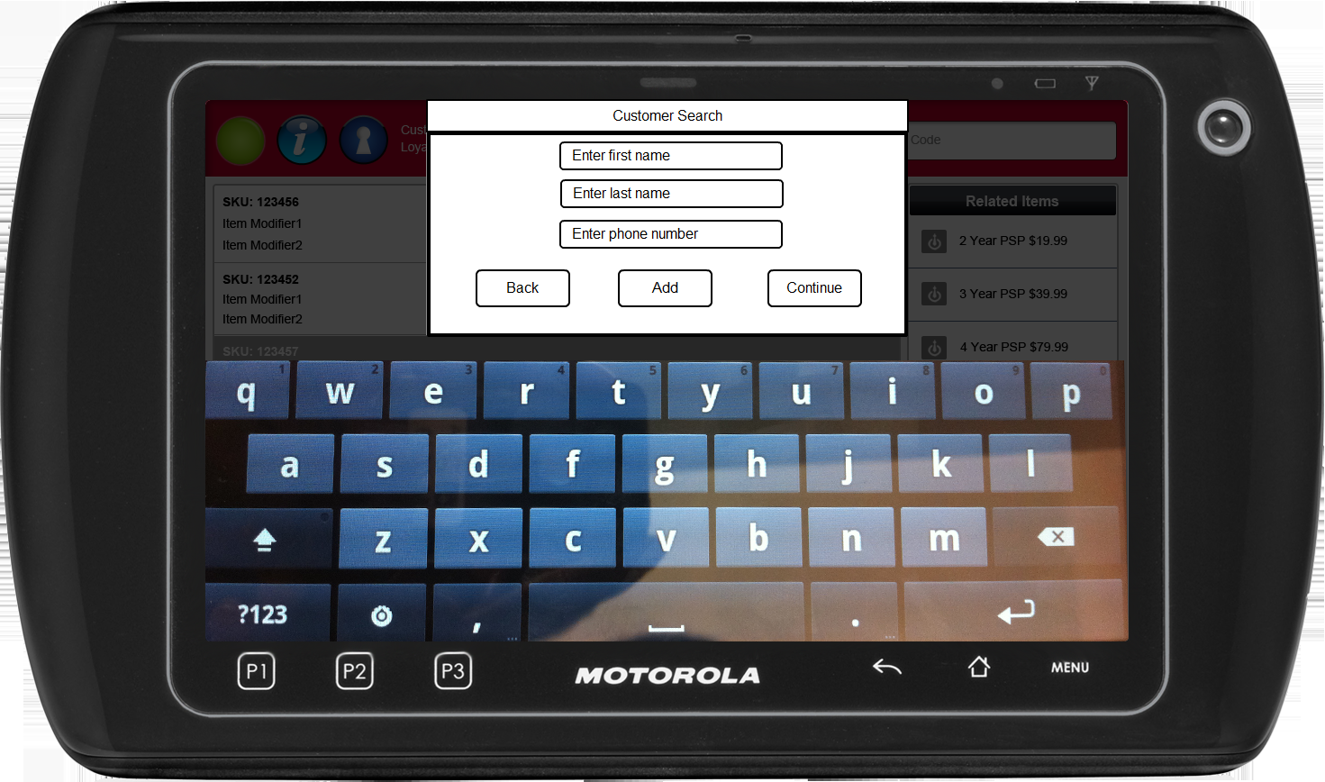

Figure 1: Customer Search

### Instruction Text

|  |
| --- |
| Instructions |
| None |

### Navigation/Menu Key

|  |  |  |  |
| --- | --- | --- | --- |
| **Label** | **State** | **Next Screen** | **Notes** |
| Back | Enabled | Calling use case | None |
| Add | Enabled | Customer Add | None |
| Continue | See Note | * Required field missing: Enter Last Name or 10 digit Phone Number * No Results Found: No Results Found * More Than One Result Found: Customer Search Result * One Result Found: Customer Details | If no criteria entered, Continue button is disabled. Otherwise, the Continue button is enabled. |

### Data/Input Field

|  |  |  |  |  |  |  |
| --- | --- | --- | --- | --- | --- | --- |
| **Label** | **Editable** | **Req’d?** | **Data Type** | **Min**  **Length** | **Max**  **Length** | **Notes** |
| Enter first name | Yes | No | Alphanumeric | 1 | 14 | None |
| Enter last name | Yes | See Note | Alphanumeric | 1 | 14 | At least one search criteria must be entered.  **Note:** If entering in Name, either Last Name or Phone Number has to be populated. First Name is not required. |
| Enter phone number | Yes | See Note | Numeric | 10 | 10 | At least one search criteria must be entered |

### Reason Code

|  |  |  |
| --- | --- | --- |
| Reason Code | Valid Values | Default Value |
| None |  |  |

### No Results Found

|  |  |
| --- | --- |
| Description | This message is displayed when a search returns no results (due to no results being found or the system is offline or the search times out) and informs the operator that the requested search returned no data. Upon acknowledging the message, the system returns to the previous screen. |
| Message | No results found. |
| Key prompt | OK |
| Notes | Configurable message |

### Missing Data Notice

|  |  |
| --- | --- |
| Description | The Missing Data Notice informs the operator that the data entered in the required fields is missing. Upon acknowledging the message, the system returns to the previous screen. |
| Message | Required field missing: Enter Last Name or 10 digit Phone Number |
| Key prompt | OK |
| Notes | Configurable message |

## Customer Search Results

The Customer Search Results screen appears when the Customer Lookup Service returns with results. The system displays all results returned from the service and displays the First and Last Name, Phone Number and Address Line 1 for each result returned.

### Mockup

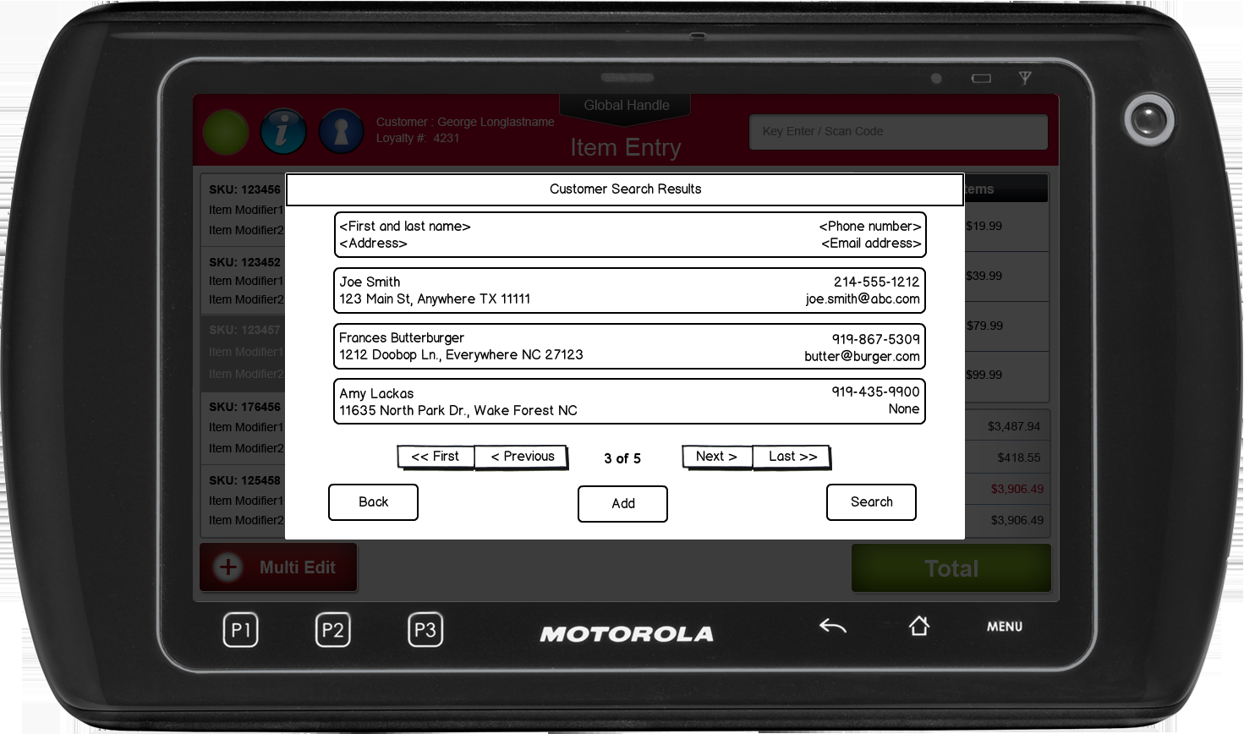

Figure 2: Customer Search Results

### Instruction Text

|  |
| --- |
| Instructions |
| None |

### Navigation/Menu Key

|  |  |  |  |
| --- | --- | --- | --- |
| **Label** | **State** | **Next Screen** | **Notes** |
| Back | Is the key enabled or disabled | * List the next screen that appears when the key is selected * If the next screen is a screen in another use case, call out the use case. e.g.: Operator Sign On use case * If there is more than one ‘Next’ option, use a bulleted list to identify each option. | Any important notes such as where the initial focus is, if the State of the key is dynamic, etc. |
| N/A | Enabled | Customer Details | Tapping on the row selects the customer |
| Add | Enabled | Customer Add | None |
| Search | Enabled | Customer Search | None |

### Data/Input Field

|  |  |  |  |  |  |  |
| --- | --- | --- | --- | --- | --- | --- |
| **Label** | **Editable** | **Req’d?** | **Data Type** | **Min**  **Length** | **Max**  **Length** | **Notes** |
| Customer Search Results | N/A | N/A | N/A | N/A | N/A | * Displays First and Last Name, Phone Number and Address Line 1 for each customer * The system displays the first phone number available in the following order: Mobile, Home and Work. * Tapping on the row selects the customer |

### Reason Codes

|  |  |  |
| --- | --- | --- |
| Reason Code | Valid Values | Default Value |
| None |  |  |

## Customer Add

The Customer Add screen appears when the operator chooses to create a new customer. The screen prompts the operator to enter the details required to create and save a customer record.

### Mockup

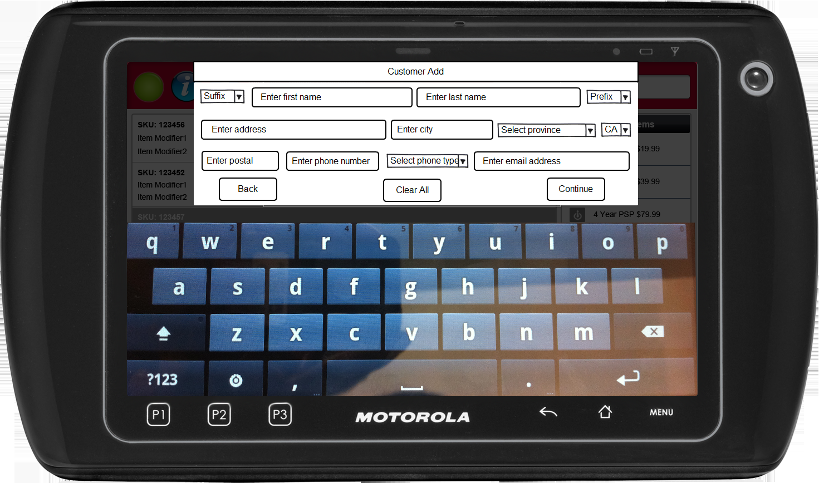

Figure 3: Customer Add

### Instruction Text

|  |
| --- |
| Instructions |
| None |

### Navigation/Menu Keys

|  |  |  |  |
| --- | --- | --- | --- |
| **Label** | **State** | **Next Screen** | **Notes** |
| Back | Enabled | Previous screen | None |
| Reset Form | Enabled | Customer Add | Removes data in all data fields |
| Add | Enabled | * Invalid Data Present: Invalid Data Notice * Valid Data: Customer Details | Adds and creates new customer |

### Data/Input Fields

| **Label** | **Editable** | **Req’d?** | **Data Type** | **Min**  **Length** | **Max**  **Length** | **Notes** |
| --- | --- | --- | --- | --- | --- | --- |
| Select Prefix | Yes | No | List Box | N/A | N/A | None |
| Enter Phone Number | Yes | See Notes | Numeric | 10 | 10 | Value is pre-populated with data from results when applicable. |
| Select Suffix | Yes | No | List Box | N/A | N/A | None |
| Enter First Name | Yes | Yes | Alphanumeric | 1 | 14 | None |
| Enter Last Name | Yes | Yes | Alphanumeric | 1 | 14 | None |
| Enter Address | Yes | Yes | Alphanumeric | 1 | 30 | None |
| Enter City | Yes | Yes | Alphanumeric | 1 | 20 | None |
| Select Country | Yes | Yes | List Box | N/A | N/A | Default value is the store country |
| Select State/  Province | Yes | Yes | List Box | N/A | N/A | None |
| Enter Postal Code | Yes | Yes | Alphanumeric | 5 | 6 | Validation is done against postal code and Province. |
| Enter Email Address | Yes | See Note | Alphanumeric | 1 | 256 | At least one search criteria must be entered Data type is Alphanumeric, with additional validation that it includes at least a @ and ‘.’ |

### Reason Codes

| Reason Code | Valid Values | Default Value |
| --- | --- | --- |
| Prefix | * Blank * Mr. * Ms. * Mrs. | Defaults to blank value |
| Province | * Alberta * British Columbia * Manitoba * New Brunswick * Newfoundland and Labrador * Northwest Territories * Nova Scotia * Ontario * Prince Edward Island * Quebec * Saskatchewan * Yukon * Includes all states/provinces for all countries listed above. | Defaults to first value in list |
| Country | * Canada | Store’s country |
| Suffix | * Blank * Jr. * Esq. * III | Defaults to blank value |

### Invalid Data Notice

|  |  |
| --- | --- |
| Description | The Invalid Data Notice informs the operator that the data entered in the required fields is invalid (e.g. incorrect format, missing). The <ARG> described in the Message is replaced with the name of the data field that contains the invalid data. If there are multiple data fields with invalid data, the system only displays the name of the first data field with invalid data. Upon acknowledging the message, the system returns to the previous screen. |
| Message | The following field has invalid data: <ARG>. Please correct the invalid data. |
| Key prompt | OK |
| Notes | This is a generic message to be reused when required data is incorrect or missing. |

## Customer Details

The Customer Details screen appears once the operator selects a customer from the search results or the search returns a single customer record. The screen displays the customer details and provides the option to edit the customer information.

### Mockup

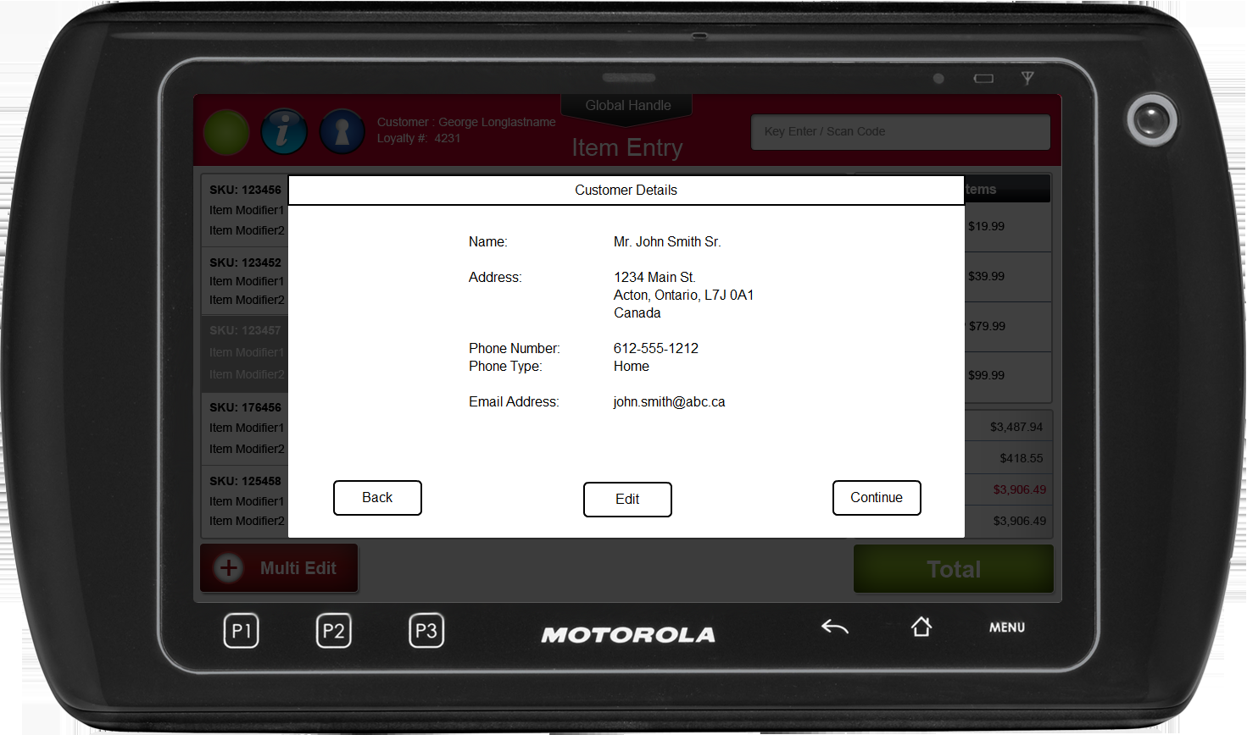

Figure 4: Customer Details

### Instruction Text

|  |
| --- |
| Instructions |
| None |

### Navigation/Menu Keys

|  |  |  |  |
| --- | --- | --- | --- |
| **Label** | **State** | **Next Screen** | **Notes** |
| Back | Enabled | Previous screen | None |
| Edit | Enabled | Customer Edit | None |
| Continue | Enabled | Calling use case | None |

### Data/Input Fields

| **Label** | **Editable** | **Req’d?** | **Data Type** | **Min**  **Length** | **Max**  **Length** | **Notes** |
| --- | --- | --- | --- | --- | --- | --- |
| Phone Number | N/A | N/A | N/A | N/A | N/A | Display only |
| Prefix | N/A | N/A | N/A | N/A | N/A | Display only |
| First Name | N/A | N/A | N/A | N/A | N/A | Display only |
| Last Name | N/A | N/A | N/A | N/A | N/A | Display only |
| Suffix | N/A | N/A | N/A | N/A | N/A | Display only |
| Address | N/A | N/A | N/A | N/A | N/A | Display only |
| City | N/A | N/A | N/A | N/A | N/A | Display only |
| State/  Province | N/A | N/A | N/A | N/A | N/A | Display only |
| Country | N/A | N/A | N/A | N/A | N/A | Display only |
| Postal Code | N/A | N/A | N/A | N/A | N/A | Display only |
| Email Address | N/A | N/A | N/A | N/A | N/A | Display only |

### Reason Codes

| Reason Code | Valid Values | Default Value |
| --- | --- | --- |
| None |  |  |

## Customer Edit

The Customer Edit screen appears when the operator chooses to edit a customer record. The screen displays the customer’s information and allows the operator to update the information. The system pre-populates all customer data when applicable.

### Mockup

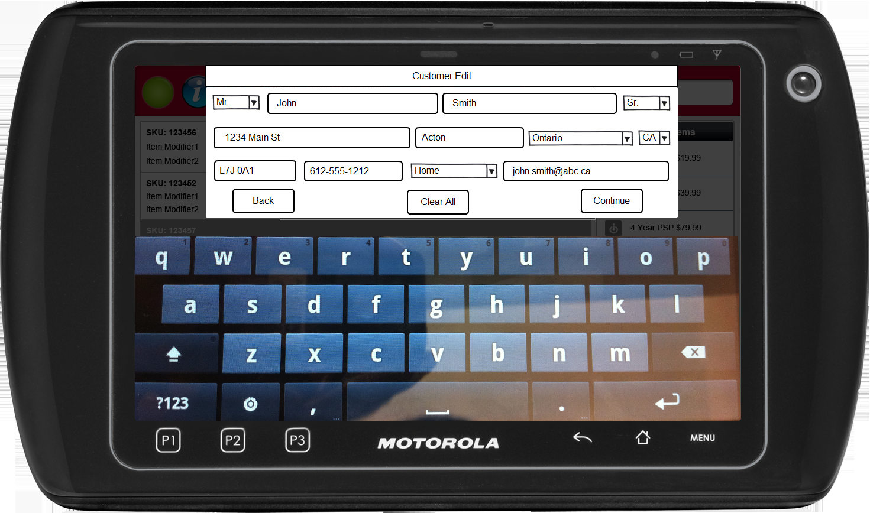

Figure 5: Enter Customer Details

### Instruction Text

|  |
| --- |
| Instructions |
| None |

### Navigation/Menu Keys

|  |  |  |  |
| --- | --- | --- | --- |
| **Label** | **State** | **Next Screen** | **Notes** |
| Back | Enabled | Previous screen | None |
| Reset Form | Enabled | Customer Edit | Removes data in all data fields |
| Continue | Enabled | Customer Details | None |

### Data/Input Fields

| **Label** | **Editable** | **Req’d?** | **Data Type** | **Min**  **Length** | **Max**  **Length** | **Notes** |
| --- | --- | --- | --- | --- | --- | --- |
| Select Prefix | Yes | No | List Box | N/A | N/A | None |
| Enter Phone Number | Yes | See Notes | Numeric | 10 | 10 | Value is pre-populated with data from results when applicable. |
| Select Suffix | Yes | No | List Box | N/A | N/A | None |
| Enter First Name | Yes | Yes | Alphanumeric | 1 | 14 | Value is pre-populated with data from results when applicable. |
| Enter Last Name | Yes | Yes | Alphanumeric | 1 | 14 | Value is pre-populated with data from results when applicable. |
| Enter Address | Yes | Yes | Alphanumeric | 1 | 30 | Value is pre-populated with data from results when applicable. |
| Enter City | Yes | Yes | Alphanumeric | 1 | 20 | Value is pre-populated with data from results when applicable. |
| Select Country | Yes | Yes | List Box | N/A | N/A | None |
| Select State/  Province | Yes | Yes | List Box | N/A | N/A | None |
| Enter Postal Code | Yes | Yes | Alphanumeric | 5 | 6 | Validation is done against postal code and Province. |
| Enter Email Address | Yes | See Note | Alphanumeric | 1 | 256 | At least one search criteria must be entered Data type is Alphanumeric, with additional validation that it includes at least a @ and ‘.’ |

### Reason Codes

| Reason Code | Valid Values | Default Value |
| --- | --- | --- |
| Prefix | * Blank * Mr. * Ms. * Mrs. | Defaults to blank value |
| Province | * Alberta * British Columbia * Manitoba * New Brunswick * Newfoundland and Labrador * Northwest Territories * Nova Scotia * Ontario * Prince Edward Island * Quebec * Saskatchewan * Yukon * Includes all states/provinces for all countries listed above. | Defaults to first value in list |
| Country | * Canada | Store’s country |
| Suffix | * Blank * Jr. * Esq. * III | Defaults to blank value |

### Invalid Data Notice

|  |  |
| --- | --- |
| Description | The Invalid Data Notice informs the operator that the data entered in the required fields is invalid (e.g. incorrect format, missing). The <ARG> described in the Message is replaced with the name of the data field that contains the invalid data. If there are multiple data fields with invalid data, the system only displays the name of the first data field with invalid data. Upon acknowledging the message, the system returns to the previous screen. |
| Message | The following field has invalid data: <ARG>. Please correct the invalid data. |
| Key prompt | OK |
| Notes | This is a generic message to be reused when required data is incorrect or missing. |

# *Business Sign Off*

|  |  |  |
| --- | --- | --- |
| Name | Organization | Date |
| <Name of signer> | <Organization of signer if applicable> | <date of sign off> |

# *Revision History*

|  |  |  |  |
| --- | --- | --- | --- |
| **Reviser** | **Revision** | **Date** | **Version** |
| Jason Hobson | Finalized version | 5/1/2012 | 1.0 |
| Amy Byers | * Section 2.4.1: Added prefilling data if from a customer search. * Section 2.6.2: Added storing data in the database. * Section 7: Added requirement matrix. | 9/25/2014 | 1.1 |
| Amy Byers | * Section 7: Added requirements to requirement matrix. | 10/6/2014 | 1.2 |

# Appendix : Source Documentation

* Requirement Specification - XPOS.xlsx

## Functional Requirements

| **ID** | **Sub Category** | **Description** | **Section(s)** |
| --- | --- | --- | --- |
| 2.11.1 | Customer Capture | If a user enters search criteria and selects to 'Add' a new record**,** then corresponding fields on the 'Enter Customer Details' screen will be pre-populated with the search criteria that was previously entered on the 'Search for Customer' screen. | * 2.4.1 Customer Add |
| 2.13.1 | Customer Capture | Updated customer records will be saved in the main customer database. | * 2.6.2 Data Input/Output |
| 2.9 | Customer Capture | If the Customer Lookup database is offline, a user may manually enter customer information and continue with the transaction. | * 1.3 Parameters and System Settings * 2.3 Main Flow * 2.6 Special Requirements * 4.1.6 No Results Found |
| 2.10 | Customer Capture | When customer capture is presented, it will be prepopulate with previously captured data (if applicable). | * 2.4.1 Customer Add |
| 2.16.1 | Customer Capture | Customers will not be required to interact with any device in order to validate the captured information (Both system prompted and user initiated customer capture). | * 2.3 Main Flow |

# *Appendix : Glossary*

|  |  |
| --- | --- |
| Term | Definition |
|  |  |